CS575 Homework 3

Upload the final pdf file on Blackboard by 11:59 pm on April 27. No late submission will be accepted this time.

- [10%] Show that there can be more than one minimum spanning tree in an undirected graph by giving an example.

- [10%] Write a brief yet clear pseudo code that extends the breadth first search algorithm to find all connected components in an undirected graph.

- [10%] Briefly prove that a complete undirected graph G with n vertices has n(n-1)/2 edges.

- [10%] Use Prim’s algorithm to find the minimum spanning tree in the following graph starting from vertex B. Show every step using the format in the Prim’s algorithm slide in Chapter 9.
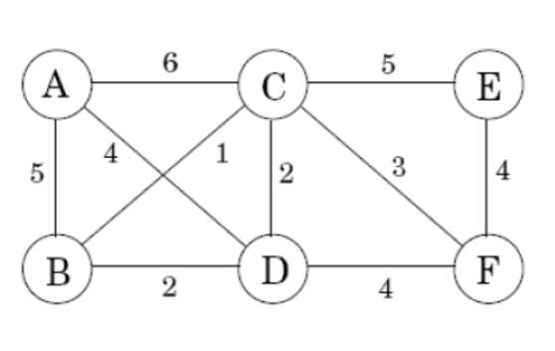
- [10%] Find a minimum spanning tree in the following graph using Kruskal’s algorithm. Show every step.
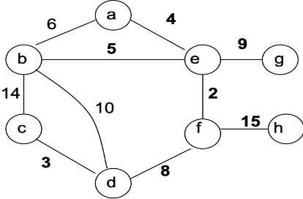
- [10%] Using Dijkstra’s algorithm, find all the shortest paths to visit all the vertexes starting from vertex s in the following graph.
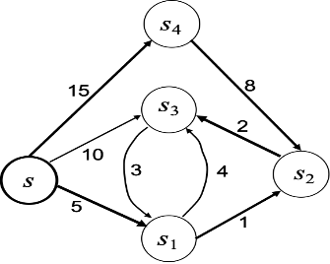
- [15%] Suppose the capacity of the knapsack is 30 and the set of items S = {(item₁ , 5, $50 ), ( item₂, 10, $60 ) (item₃ , 20, $140 ) } where each element of set S represents (item, weight, profit). Given this information, solve the 0/1 knapsack problem using the following algorithms.

(a) [3%] Solve it using the Greedy 4 (highest benefit per unit weight first) algorithm.
Answer: Done in class. (See Chapter 12.)

(b) [4%] Solve it using the brute force method.
Answer: See Chapter 12.

(c) [8%] Solve it using the dynamic programming algorithm.

- [10%] Suppose that you have n professional boxers and a list of k pairs of boxers with rivalries. (Between any pair of boxers, there may or may not be a rivalry.) Give an O(n+k) time algorithm that determines whether it is possible to designate some of the boxers to Black team and the remainder as White team such that each rivalry is between a Black and a White team member. If it is possible to perform such an assignment, your algorithm should produce it.

- [9%] Find the longest common subsequence (LCS) between two strings BCDE and BCAD via dynamic programming. Show your final solution in the table that shows the length of the LCS and arrows. Also, write down the LCS you found. Your table and LCS should be consistent with each other.

- [6%] Just enumerate the nodes in the following graph in (a) BFS order [3%] and (b) DFS order [3%], starting from node 1. No explanation is needed.
1
2
3
4
5
6
7

